Southern New Hampshire University

9-2 Final Project: Dashboard

Adam M. Lang

DAT-530-X5611 Present & Visualize Data 19TW5

Professor: Bindu George, Ph.D.

13 October 2019

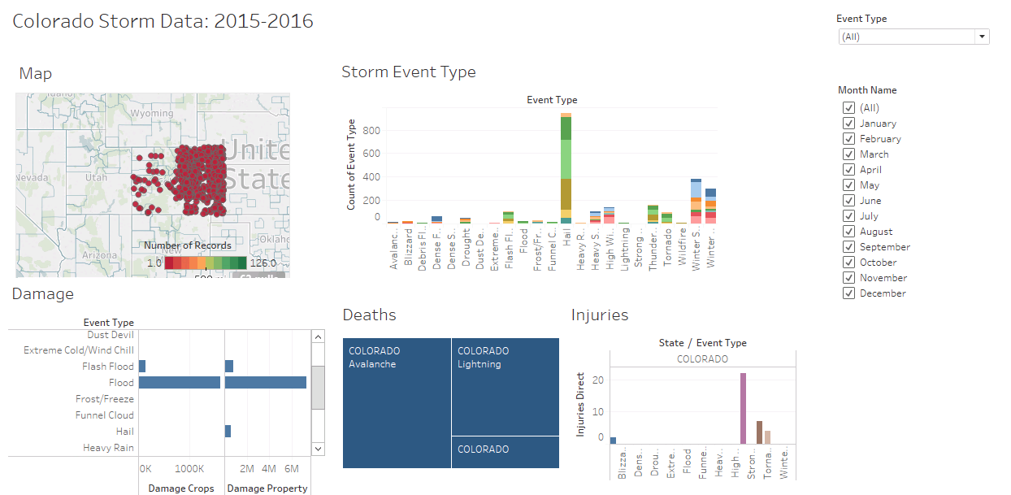

Fig. 1. Dashboard Main Screen

**Instructions for use**

This dashboard visualization was constructed for the Colorado Emergency Management Agency (EMA). The right hand corner has filters that include all weather events that occur in the state, and each month below that. You can filter the entire dashboard by clicking on selective filter boxes. Starting at the upper left hand side of the dashboard there is a map that has all weather events and their geographic longitude and latitude. The next visualization to the right is the “Storm Event Type”. This is every storm event that occurs in Colorado. Based on how many months you filter, the stacked bar graph will show numerous months at once. If you click over each color of the stacked bar graph it tells you the month, the weather event and the count number of that event that occurred. Moving to the bottom left hand corner there is the “Damage” visualization, which is perhaps the most important visualization for the EMA to see. It includes all Damage Crops and Damage property for each weather event and you can filter based on month. The next visual to the right of that is “Deaths” and a Tree map shows the hierarchy of those weather events causing deaths and on the “all filter” it shows there were only 3 weather events causing deaths: avalanches, lightning and thunderstorm wind. Lastly, there is the Injuries graph. This shows all injuries caused by each weather event and again you can filter above by months and event.

The EMA can contact our data science department for feedback and questions regarding the dashboard presentation the following ways:

* 1-720-WEA-DATA
* Email: [coloradoweatherdata@colorado.gov](mailto:coloradoweatherdata@colorado.gov)
* We will also set up a discussion and chat session in the coming weeks either via teleconference or in-person meeting.

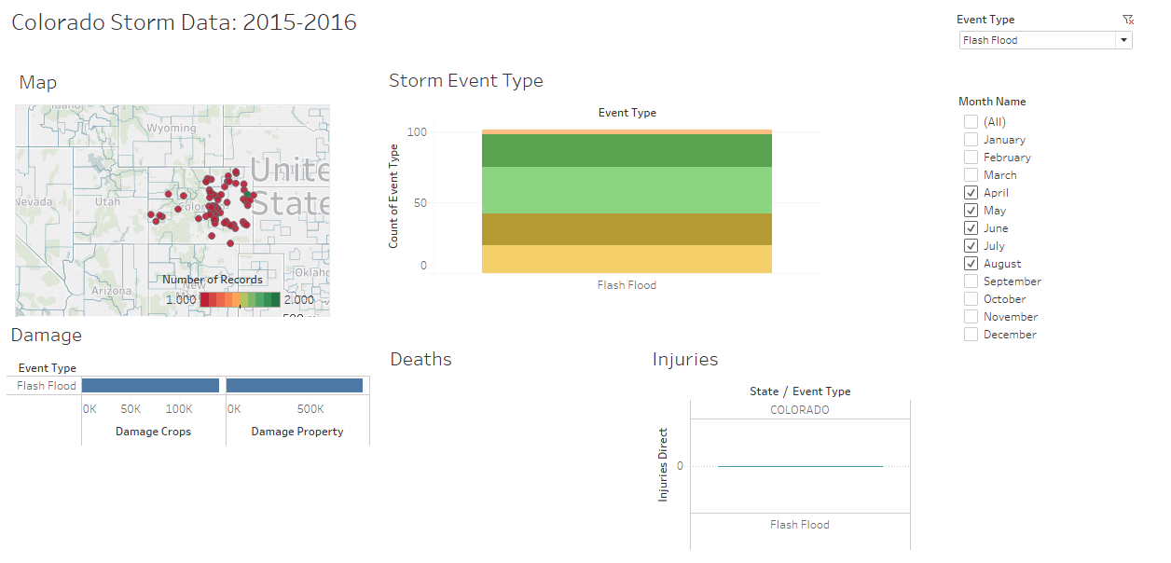

Fig. 2. Flash Floods drilled through on the dashboard during the highest months at risk: April – August

This drill through shows all Flash Floods during the Flash flood season of April – August. As you can see there are numerous locations state wide. You can scan over each location and it will show up how many flash floods were reported at each geographic point. The Storm Event Type graph shows all months total event count for flash floods starting at the top with April and going down to August on the bottom. The Damage graph shows there were over 100k Damaged crops and over 500k damaged property. There were no deaths and no injuries. This information is important for the EMA to know where they need to prepare to station their crews geographically and during what months. It also gives them a count on how many damaged properties and crops occur during flash flooding.

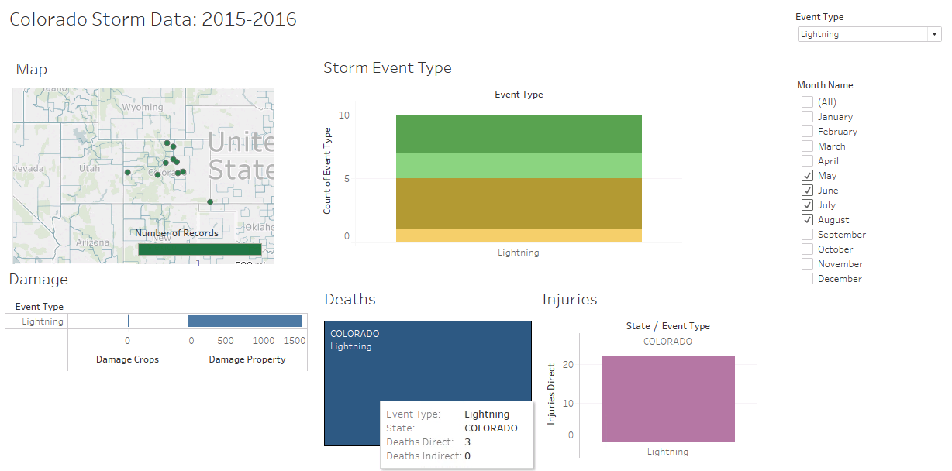

Fig. 4. Lightning Strikes during the spring and summer.

This drill through shows all lightning strikes during the months that this most commonly occurs. Again the geographic locations of these are shown on the map above. The Storm Event Type shows May on the top to August on the bottom. July is brown on this graphic and had the most lightning strikes occur. The Damage graph shows there was 1500k in damage property. There were 3 deaths during this time frame from lightning strikes and you can scan over the tree map to see that above. There were 22 injuries that occurred during these months as seen on the Injuries graph.

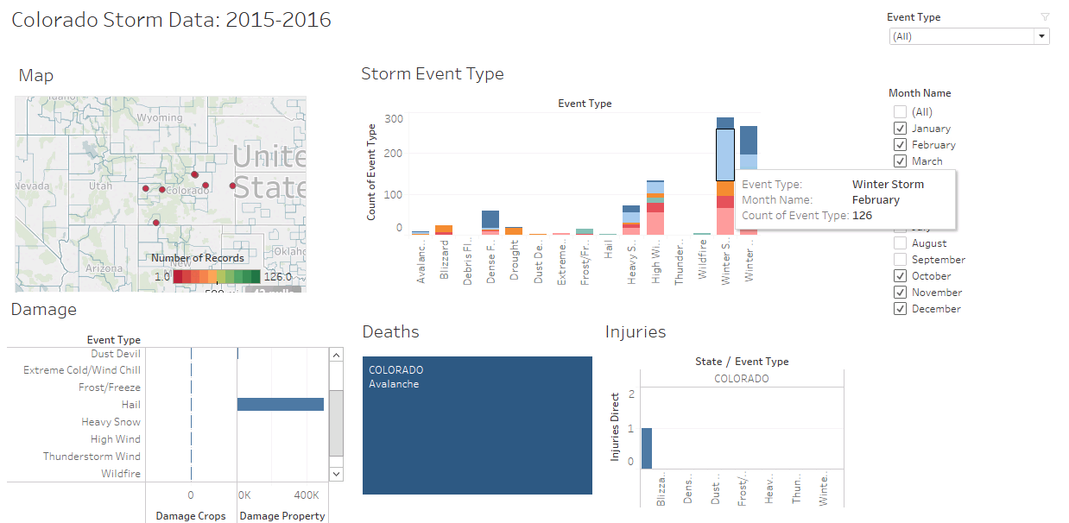

Fig. 5. All weather events for Fall and Winter

All weather events for fall and winter are shown above. The map actually only shows the hail events recorded and their geographic locations as they were the only events reported geographically for this time frame. I scanned over the Winter Storms month that had the most storms (February) and you can see it shows up in the box above. Hail is the primary cause of damaged property about 400k total. Avalanche is the only weather event that caused death.

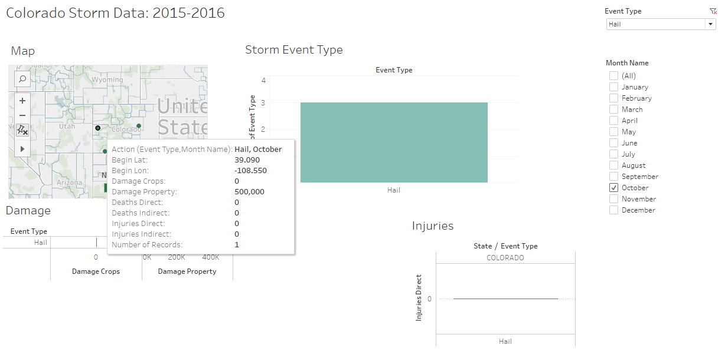

Fig. 6. Hail in the month of October.

All hail in the month of October is shown in the dashboard drill above. I focused on the map here so that you can see when you scan over a geographic point as in this case, it will show where the most damaged property occurs (it is occluded by the box that pops up) but it is the same number as in the Damage graph, which is about 500k. There were 3 events for hail in the month of October. There were no deaths and no injuries.

References

* NOAA 2015-2016 Storm Events Data Set. Retrieved from: https://ncdc.noaa.gov/stormevents/